**CMPE-250 Laboratory Exercise Eight**

**Multiprecision Arithmetic**

By submitting this report, I attest that its contents are wholly my individual writing about this exercise and that they reflect the submitted code. I further acknowledge that permitted collaboration for this exercise consists only of discussions of concepts with course staff and fellow students; however, other than code provided by the instructor for this exercise, all code was developed by me.



Dean Trivisani

Performed October 24, 2017

Submitted October 30, 2017

Lab Section 01L2

Instructor: Melton

TA: Donald Mannise

Michael Baumgarten

Matthew Toro

Lecture Section 01

Professor: Melton

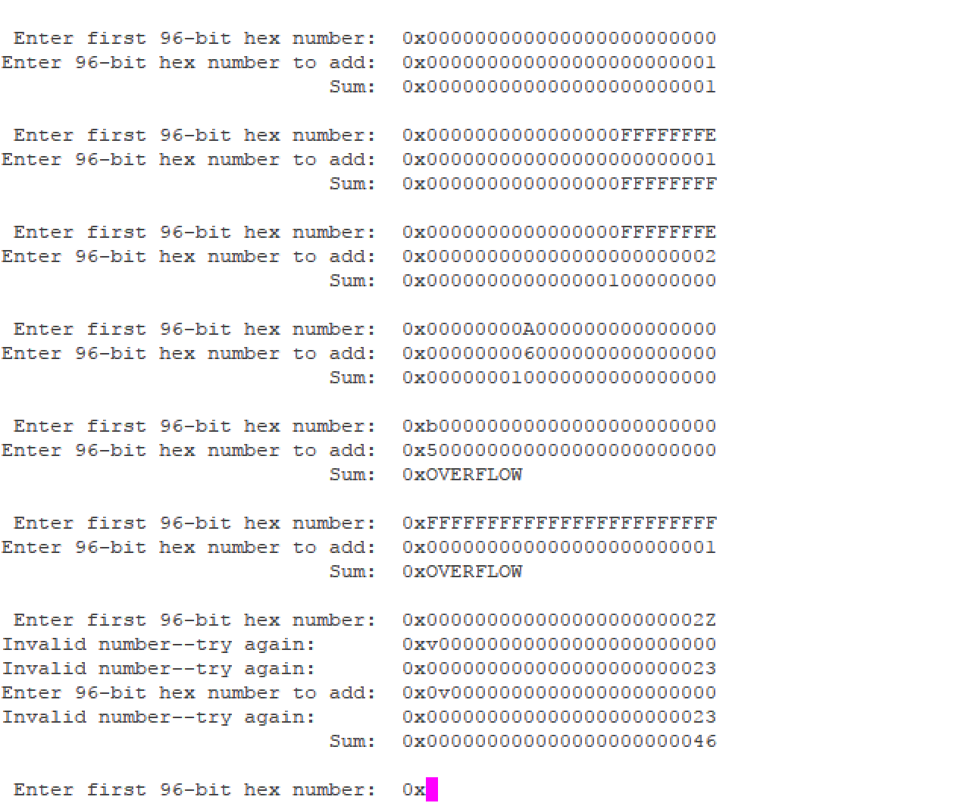

This screen capture shows the testing of the multiprecision arithmetic subroutine. It shows operations involving overflow, carries, and invalid input characters, as well as the ability to handle both upper and lowercase letters. The outputs are identical to those in the lab documentation (with improved formatting), and thus are correct.

**Subroutines Starting Addresses Size (bytes)**

AddIntMultiU 0x00000489 92

GetHexIntMulti 0x000004e5 148

PutHexIntMulti 0x00000579 42

Reset_Handler 0x00000411 118